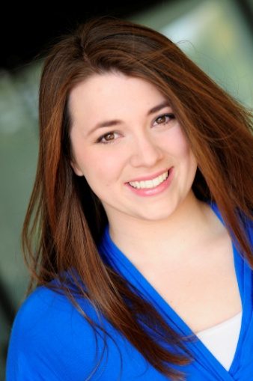
Lizzie Klemm
St Louis, MO

Hair Color: Brown Eye Color: Brown
Height: 5’4” (314) 809-6671

lizzieklemm@gmail.com

NATIONAL TOURS
PAW Patrol Live! The Great Pirate Adventure Zuma VStar (via Cirque Du Soleil)
PAW Patrol Live! Race to the Rescue Zuma VStar (via Cirque Du Soleil)
PAW Patrol Live! Race to the Rescue Swing/Chicken Cheerleader VStar Entertainment Group
THEME PARK
Six Flags – Holiday in the Park 2016-2017 Holiday Harmonies Soprano Six Flags St. Louis
Six Flags – Fright Fest Love at First Fright – Katie Six Flags St. Louis
Six Flags – That’s Entertainment Swing Six Flags St. Louis
Universal Studios Florida Halloween Horror Nights Scareactor Universal Orlando
Disney Cruise Line – Disney Wonder Face Character/Mover/Mainstage U/S Disney Parks and Resorts
Walt Disney World Resort Entertainment - Character Performer Disney Parks and Resorts
Walt Disney World Resort Candlelight Processional Cast Choir Disney Parks and Resorts REGIONAL THEATRE
A Musical Christmas Carol Julia/Ensemble Round Barn Theatre
42nd Street Winnie/Female Ensemble Tent Theatre
Guys and Dolls Agatha/Bobby Soxer Tent Theatre
Footloose Teen Ensemble The St. Louis Muny
Godspell Teen Ensemble The St. Louis Muny
Miss Saigon Teen Ensemble The St. Louis Muny
Les Misérables Teen Ensemble The St. Louis Muny
Grease Teen Ensemble The St. Louis Muny
Aida Teen Ensemble The St. Louis Muny
UNIVERSITY THEATRE
The Pirates of Penzance Mabel Missouri State University
Sweeney Todd Ensemble Missouri State University
Cabaret Helga-Kit Kat Girl Missouri State University
EDUCATIONAL THEATRE
In-School Players Performer Missouri State University
Syncopation Performer Missouri State University
Beauty and the Beast Belle DramaRamaTheatre Company
DANCE
Rhythm and Ritual, Transfer Points Dancer Missouri State University
FILM
Pointe of Contact Michelle Graham Missouri State Student Film
TRAINING
Bachelor of Fine Arts – Musical Theatre Missouri State University 2014
Acting for the Camera Kurt Gerard Heinlein
Acting MSU, Stages, COCA
Shakespeare Performance Sarah Wiggin
Vocal Paula Patterson, Lisa Campbell-Albert
Dance MSU, COCA, Stages, On Your Toes
Audition Intensive American Acad. of Dramatic Arts - LA
Dance Workshop Deidre Goodwin and Michelle Potterf
Dance Workshop Broadway Dolls
Vocal Workshop Andrew Byrne, Kim Crosby
Vocal Workshop Kyle Dean Massey
Vocal Workshop Joey Contreras and Natalie Weiss
Dance/Singing Workshop Deidre Goodwin and Kim Stern

Special Skills: Vocal Range D#3 – F6 (1st soprano), Basic Conversational Spanish, Advanced/Intermediate Trampoline, Basic Acro, Armed (rapier) and unarmed combat, English Dialect (RP/Cockney), Hand Puppetry

